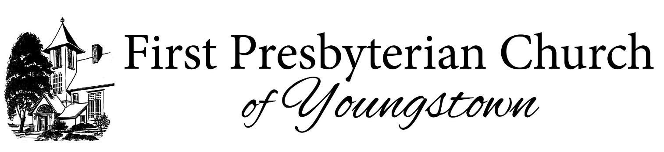

|  |
| --- |
|  |

**Job Posting**

**Associate Pastor of Family Life, Youngstown NY**

Would you like to join one of the most dynamic, vibrant, faith-based communities in Western New York? The role of Associate Pastor of Family Life is perfect for the clergy leader called to serve a small, charming community who embodies its motto “Young in Spirit, Ageless in Pride”.

We anticipate our new Associate Pastor of Family Life will directly address key congregational priorities centered around the emerging needs in the community, such as an aging population and a growing need to enrich programs for our youth and families. These areas are key to the framework around which our associate pastor should form their ministry and will be built on the strong foundation developed by many hands throughout the church in recent years. With purposeful leadership and community-building we will achieve meaningful growth in these areas.

*James 2:18 “But someone will say, “You have faith and I have works.” Show me your faith apart from your works, and I will show you my faith by my works.”*

**Responsibilities include:**

Leading Children’s and Youth Ministry – 50%

* Lead the overall operation of the Church’s Youth and Children’s Ministry Programs, nurturing young people in their faith journey from birth through 12th grade.
* Plan and supervise weekly Children’s message and Sunday school worship services and special programs (Christmas Pageant, Vacation Bible School, Youth Mission Trips, Youth Program Fundraising, etc.).
* Maintain regular correspondence with parents, youth, and church family through multiple media including: phone, email, social media, text messages, church newsletter, Sunday bulletin and annual report.
* Facilitate Youth and Children’s Ministry Committee meetings on a quarterly basis, and an annual committee retreat.

Pastoral Care – 40%

* Along with the Pastor and Deacons, visit those in nursing homes, assisted living, hospitals, or confined to their homes. Stay abreast of people in need though attendance at worship services and at various social gatherings involving church members.
* Provide pastoral services for those in crisis situations.
* Encourage all members to care for each other as well as the neighbor in need.

Support Worship Leadership – 10%

* Inspire the congregation through carefully prepared and artfully delivered sermons, articulating a clear and consistent theology, delivered on average one Sunday/month and in the Pastor’s absence.
* As-needed, conduct funerals and memorial services, baptisms and weddings, and administer communion.
* Perform other pastoral duties in backup to, and as requested by, the lead pastor.

**Qualifications:**

* Ordained in the Presbyterian Church USA and minimally, possess a Master of Divinity degree from a seminary accredited by the Association of Theological Schools (ATS).
* Possess a strong desire to nurture church members of all ages in the Reformed tradition of the Christian faith as expressed within the Presbyterian Church.
* A personal spiritual life, and an ability to tell what his or her faith is in understandable words.  A clear commitment to Christ and an assurance of a call to ministry.
* Must be committed to providing a safe, nurturing and supportive environment of mutual respect and encouragement.
* Excellent written and verbal communication and interpersonal skills with the ability to effectively preach to the congregation, communicate with children and parents or those in personally stressful situations.
* Some clinical pastoral education (understanding of counseling procedures).  The person should understand that he or she is not a professional psychologist or social worker and understand when to refer people to those with that competence.
* Must be knowledgeable of the spiritual, physical, recreational, social and psychological development of youth.
* Motivated, energetic, fun, loving, caring and has a sense of humor.

**Job Type:**This is a full-time position of 40 (forty) or more hours of work per week. The exact number of hours may vary from week to week, especially in busy times.

**Salary:** Final salary will be determined based on successful candidate’s experience.

Please send resume and cover letter to [YPC.APNC@gmail.com](mailto:YPC.APNC@gmail.com)

*The First Presbyterian Church of Youngstown is committed to creating a diverse environment and is proud to be an equal opportunity employer. All qualified applicants will receive consideration for employment without regard to race, color, religion, gender, gender identity or expression, sexual orientation, national origin, genetics, disability, age, veteran status, or any other protected category under applicable law.*